Module 7: Critical Thinking – Capstone Project
Julian A. Sneve
Colorado State University Global
MIS581: Capstone – Business Intelligence and Data Analytics
Dr. Orenthio Goodwin
October 26, 2025

Module 7: Critical Thinking – Capstone Project
Abstract
This capstone project investigates the integration of ABC/XYZ inventory classification with predictive time-series forecasting to enhance retail inventory optimization. Using the synthetic DataCo Smart Supply Chain dataset, the study examined 37 months of transactional data to determine which products generated the most profit, which displayed the highest demand variability, and whether seasonality significantly influenced demand across XYZ categories. Statistical methods including autocorrelation (ACF & PACF) and Ljung-Box white-noise testing were employed to evaluate seasonal patterns in demand. Results from the ABC analysis revealed a “super-Pareto” distribution in which a small number of products accounted for a disproportionate share of total profit, while the XYZ classification showed nearly equal distributions of stable (X) and highly variable (Z) products with a small percentage of products having marginal variability. The combined ABC/XYZ matrix highlighted that most products were low-value with unpredictable demand. Seasonality tests identified weak cyclical patterns in X and Y groups but none in Z, indicating that variability was largely stochastic rather than seasonal. For this reason, the null hypothesis that seasonality has no significant effect on demand variability across XYZ categories could not be rejected. These findings suggest that dynamic, data-driven forecasting models should be applied selectively with seasonal approaches for stable or moderately variable items and non-seasonal or probabilistic methods for more volatile products.

Introduction
Throughout my career, I have held a range of roles in inventory management and warehouse operations, experiences that revealed the immense potential of supply chain management as a data-rich field where analytics can create significant value. This insight has shaped my decision to focus my capstone project on inventory optimization and demand, areas critical in today’s fast-paced world of ecommerce where supply chain reliability directly impacts business success. Studies indicate that disruptions in the supply chain can cost companies as much as 10% of annual revenue (Davey, 2025), underscoring the importance of data-driven strategies to navigate challenges such as political unrest, rising consumer expectations, and bottlenecks. By leveraging descriptive, diagnostic, predictive, and prescriptive analytics, organizations can not only understand what has happened and why, but also anticipate future trends and determine the best actions to take, ultimately improving visibility, efficiency, and resilience across the supply chain.
Objectives
The objective of this project is to create a data-driven business intelligence (BI) platform that integrates predictive modeling for demand forecasting with statistical analysis techniques for inventory optimization. This BI platform will provide businesses the ability to quickly unconver actionable insights and improve supply chain efficiency by supporting timely, data-driven decision making.
Data analytics has become an essential tool for enhancing supply chain performance, particularly in the areas of inventory management and demand forecasting. By leveraging historical sales data, statistical algorithms, seasonal patterns, and machine learning, businesses can anticipate customer needs and make proactive decisions that improve efficiency, reduce costs, and improve margins (ASCM, n.d.). This data-driven approach provides more accurate forecasts than traditional methods, allowing companies to maintain optimal stock levels, minimize stockouts, and avoid the expenses associated with excess inventory. According to Falatouri et al. (2022), predictive analytics achieves this by accounting for multiple variables, including market trends and external influences, which enables firms to respond effectively to shifting market conditions.
The benefits extend beyond operational improvements to strategic advantages. Organizations that apply predictive analytics in their supply chains gain a competitive edge, as they can adapt more quickly to changing customer demands while rivals relying on conventional forecasting may lag behind. This adaptability not only improves customer satisfaction but also strengthens long-term competitiveness.
In addition to predictive modeling, real-time analytics plays a critical role in modern supply chains. By employing technologies such as IoT devices, sensors, and integrated data streams from multiple sources, businesses can track supply chain activities continuously and gain a comprehensive, up-to-date view of operations (Wardle, n.d.). Real-time monitoring makes it possible to identify anomalies, address disruptions, and refine strategies on an ongoing basis. Ultimately, combining predictive analytics with real-time performance tracking creates a cycle of continuous improvement, ensuring that supply chains remain efficient, resilient, and competitive in an increasingly dynamic business environment.
Overview of Study
This study examined the integration of traditional ABC/XYZ inventory classification with predictive time-series forecasting models to improve retail inventory optimization. Using the DataCo Smart Supply Chain dataset, which contained synthetic sales and distribution data for a 37-month period, the research aimed to align static product segmentation with dynamic forecasting. The project evaluated which products were most profitable, which exhibited the highest demand variability, and whether seasonal trends influenced demand patterns. Through statistical and predictive techniques the study sought to demonstrate that combining product classification and forecasting can provide a data-driven framework for accurate, adaptive inventory management.
Research Questions and Hypotheses
To meet the objectives of the project, three interrelated research questions were developed. These questions are meant to provide focus, structure, and direction to ensure the research and analysis of this project provide meaningful insights. Complimentary to each research question are both a null and alternate hypothesis. These hypotheses provide the ability to go beyond the speculative research questions to a more granular level of research, allowing for the testing of specific alternative answers to the research questions by empirical examination (Polonsky et al., 2019).
Research Questions 1 and 2
The first two questions are shared concurrently since they will share a common method for product identification known as the ABC/XYZ analysis which will be discussed in more detail in the ensuing Methods section.
- Question 1: Which products drive the most profit?
- Question 2: Which products have the most demand variability?
Knowing which products are most profitable as well as which ones have the most variability in demand is critical for a business, particularly their supply chain, to operate efficiently. Identifying products that are the most profitable allows a business to strategically focus resources to drive sales and maximize returns, while identifying which products have the most and least demand variability helps the business make more informed inventory purchases limiting stockouts and keeping storage costs low. Combining these two ideas helps businesses manage their inventory by balancing high-value products with demand predictability, optimizing stock control (Thieuleux, 2025).
- Question 1 H₀ : There is no significant difference in average profit across products.
- Question 1 H₁ : There is a significant difference in average profit for at least one product.
- Question 2 H₀ : There is no significant difference in demand variability across products.
- Question 2 H₁ : There is a significant difference in demand variability for at least one product.
Research Question 3
- Question: Does seasonality affect the stability of product demand across XYZ categories?
Recognition of seasonality and accurate forecasting of seasonal demand are both essential for inventory optimization. If a business overestimates the demand for a seasonal product, they run the risk of being stuck with excess inventory which may lead to increased storage costs and reduced profit margins. On the other hand, if demand is underestimated, the business could face stockouts causing a loss of sales and potential damage to customer relationships.
While the ability to identify products with high variability is valuable, just as valuable is to understand whether that variability is due to seasonality. Unfortunately, XYZ classification is static, based only on variation in historical data, and doesn’t account for repeating patterns such as seasonality. Identifying products that have high variability caused by predictable seasonality could possibly help improve forecast accuracy significantly
- H₀ : Seasonality has no significant effect on the variability of product demand across XYZ categories.
- H₁ : Seasonality has a significant effect on the variability of product demand across XYZ categories.
Literature Review
Effective inventory management is the foundation of supply chain efficiency, allowing organizations to balance product availability, cost, and demand uncertainty. Among the most widely applied inventory classification techniques are the ABC and XYZ analyses, both of which build upon Pareto’s principle to prioritize resources and improve control strategies (Ternero et al. 2023). ABC analysis categorizes products based on their contribution to revenue or inventory value, while XYZ analysis assesses demand variability to guide stocking decisions (Thieuleux, 2025). The combination of these methods, commonly referred to as ABC/XYZ analysis, provides a two-dimensional structure that enhances decision-making for product categorization, forecasting, and replenishment.
While extensive research has examined ABC analysis across retail, healthcare, and manufacturing, far less attention has been devoted to XYZ analysis, particularly in retail. XYZ analysis complements ABC by classifying products according to demand variability, typically measured using the coefficient of variation (Natsypayeva et al., 2020). Category X products exhibit stable demand, Y products show moderate variability, and Z products experience irregular or unpredictable patterns (Thieuleux, 2025). Despite its simplicity and proven effectiveness in managing perishable or high-criticality goods such as pharmaceuticals and medical supplies, XYZ analysis remains largely overlooked in retail. Given the sector’s complex, promotion-driven demand cycles, this gap presents an opportunity to extend XYZ analysis beyond static classification toward predictive, data-driven integration.
Natsypayeva et al. (2020) conducted one of the few retail-focused studies combining ABC and XYZ analyses. Their application in a Russian supermarket categorized dairy products by both value and demand stability, forming a nine-cell matrix that informed procurement decisions. The results demonstrated that products in the AX and BX categories (high-value, stable-demand products) required tight control and continuous availability, while CZ products (low-value, highly variable-demand products) could be de-emphasized. However, the study remained largely descriptive and did not quantitatively connect classification outcomes to predictive forecasting or model performance (Natsypayeva et al., 2020).
Similarly, Ternero et al. (2023) attempted to utilize XYZ classification to manage stochastic demand for a medical equipment company. Due to a number of products carrying a demand of zero over multiple months they opted to introduce demand coefficients of quadratic variation which grouped the products into four categories. While their work didn’t directly correlate to ABC/XYZ analysis they did introduce a combined model that integrated ABC value segmentation with demand pattern classification, evaluating forecasting techniques (e.g. ARIMA, Holt-Winters exponential smoothing, and Croston’s method) for different demand types (Ternero et al., 2023). This approach improved service levels and reduced stockouts but was primarily oriented toward spare parts logistics rather than retail inventory optimization.
Similar to the limited attention given to XYZ analysis in retail, there is also a lack of integration between established forecasting models, such as ARIMA, exponential smoothing, and moving averages, and traditional inventory classification frameworks. This review identifies these research gaps across industries and establishes a basis for integrating predictive modeling with ABC/XYZ analysis to enhance inventory optimization. Because retail demand is shaped by promotions, seasonality, and consumer behavior, predictive modeling is essential to address this complexity. The absence of empirical studies linking ABC/XYZ classification with time-series forecasting represents a clear opportunity for innovation, enabling dynamic inventory segmentation that evolves in real time based on forecasted demand variability rather than static historical patterns.
While ABC analysis has been validated as a cost-based inventory classification method across industries, and XYZ analysis has proven effective for categorizing demand variability, their combined use remains limited, especially within retail contexts. The few studies that integrate both frameworks, such as Natsypayeva et al. (2020) and Ternero et al. (2023), do so without linking to predictive modeling. Meanwhile, advanced forecasting methods like ARIMA and exponential smoothing have been effectively used to model demand in other sectors but have not yet been tied to ABC/XYZ-based inventory optimization frameworks.
In addition to traditional forecasting and classification, recent advances in machine learning (ML) also present amazing potential for supply chain manangement. Research by Ilias and Reddy (2025) demonstrated how supervised, deep learning, and reinforcement ML models can enhance predictive accuracy and operational efficiency. In applications such as ABC/XYZ classification these ML models could allow continuous reclassification of products based on demand variability and forecast updates, creating a self-improving inventory system.
Research Design
Methodology
This project aims to address the research gap between ABC/XYZ classification and predictive time-series forecasting techniques for retail inventory optimization. By aligning traditional inventory segmentation with dynamic demand forecasting and machine learning, the study seeks to advance inventory analytics from static categorization to proactive, data-driven decision-making to enhance both profitability and supply chain efficiency.
The dataset being used in the research is the DataCo Smart Supply Chain For Big Data Analysis dataset. This synthetic dataset that was created as a collaboration between Fabian Constante, Fernando Silva, and António Pereira and is hosted on the Mendeley Data website (Constante et al., 2019). Shared in the dataset are customer, sales, and distribution activity for the fictional company DataCo Global across a 37-month period, from January 2015 through February 2018 (Constante et al., 2019).
Methods
ABC/XYZ
The Pareto Principle (aka the 80/20 Rule), originally developed by Vilfredo Pareto in 1906 to describe Italy’s distribution of land wealth, stated that 80% of the land was owned by 20% of the people (Investopedia, 2025). This principle serves as the foundation for the ABC/XYZ analysis which categorizes products by profit, represented by labels A, B, or C, and demand variability, represented by labels X, Y, and Z. Statistical analysis will identify which products belong in each category. For ABC categorization products with the most profit generation are given the designation A, those with median profits are given the designation B, and the products that produce the least profits are given the designation C. Similary, for XYZ categorization the products with the lowest demand variability are given the designation X, those with moderate demand variability are given the designation Y, and the remaining products with the most demand variation are given the designation Z.
The two designations assigned to each product are then combined to further categorize each product based on both profit and demand variability. This two-value combination creates nine categories as the matrix shows in Table 1. These categories help guide inventory managers when implementing appropriate service level and safety stock targets (Lokad, 2023).
Table 1
ABC/XYZ Matrix
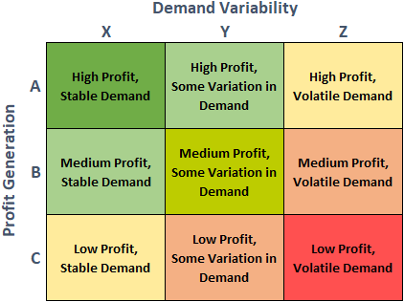
Seasonality
Autocorrelation and partial autocorrelation functions (ACF and PACF) will be applied to measure the relationship between the time series and lagged values, ultimately identifying whether product demand is seasonal or not. These two calculations work in tandem to identify seasonality with the ACF identifying overall patterns and the PACF highlighting direct correlations (Geeks for Geeks, 2025).
Limitations
Although the methodology of the study appears to be sound, a few limitations must be acknowledged. First, the dataset used was synthetic which ensured there was no threat of sharing private data but may not fully replicate unexpected real-world trends and irregularities. Second, the study focused on a single dataset representing the retail industry. This may limit the usefulness of the study toward other industries.
Ethical Considerations
The dataset used in the project poses minimal ethical risk being that it is synthetic. However, because it does include fields that simulate personally identifiable information, such as customer names and addresses, all data were treated as though they represented real-world data. Ethical standards were maintained by not sharing raw, customer-level data, instead only aggregated results were disclosed. Also, to maintain transparency and avoid any possible confusion it is explicitly stated multiple times in this paper that the data being used is synthetic.
Findings
ABC/XYZ Classification
The results of the ABC analysis found that the company’s profits were driven heavily by a small percentage of products. As can be seen in Table 2, only three products out of the 118 offered (2.5%) account for over 42% of profits, and the top 10 products accounted for nearly 90% of profits. This led to a drastic adjustment of ABC classification criteria shown in Table 3. Instead of a ratio similar to Pareto’s where it was expected that around 20% of products produced 80% of the profit this data shows 3% of products drive nearly 50% of profits with 6% of products accounting for 80% of profits. That means 94% or 111 of the products the company offers account for only 20% of profits.
Table 2
Top 10 products by profit generated
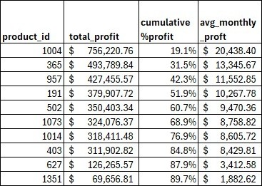
Table 3
ABC classification table
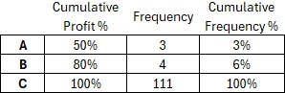
Analyzing the variability in demand for XYZ classification also produced interesting results. The results in Table 4 show that the coefficient of variance (CV) for demand of each product does not cover a broad range. Nearly half of all products (46%) have stable, predictable demand with a CV of 0. These are the X category. A small portion (10%) makes up the Y category with moderate variability. Another large portion (44%) of products have the most variability in demand and make up the Z category.
Table 4
XYZ classification table
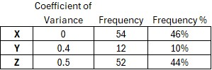
Reviewing the outcomes of the ABC and XYZ analyses in Tables 3 and 4 provide enough statistical evidence to reject both hypothesis number one, there is no significant difference in average profit across products, and hypothesis number two, there is no significant difference in demand variability across products.
After completing the ABC and XYZ analyses the two category assignments for each product are combined. Each product now lands in one of the nine groups shown in Table 1. The frequency distribution of products in the nine groups can be seen in Table 5. These results reveal only 2 products are in the AX category representing the most profitable and predictable products. The two categories with the highest number of products are CX and CZ with 51 and 48 products respectively which aligns with the ABC and XYZ distributions.
Table 5
ABC/XYZ classification table
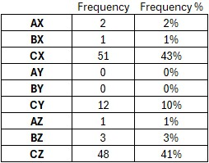
Seasonality Analysis
The results from the ACF and PACF plots (Figures 1 through 3) along with the Ljung-Box white-noise tests (Table 6) were used to evaluate whether seasonality exerts a significant influence on the variability of product demand across XYZ categories. For the X group the Ljung-Box test indicated an autocorrelation at lags 6 and 12 (p = .001 and p = .023, respectively), suggesting the presence of slightly predictable seasonal cycles. However, the autocorrelation was so slight it doesn’t stand out at either the 6 or 12 month lag in the ACF and PACF charts.
The Y group showed significant autocorrelation across all four seasonal lag increments with p-values below .01, confirming a slightly stronger seasonal element. Unfortunately, as with the X group, this correlation was too weak to present itself visually in the ACF and PACF charts.
The Z group presented no statistically significant autocorrelations at seasonal lags, and its ACF decayed rapidly. This indicates that demand fluctuations for the Z group are largely random rather than cyclical.
Table 6
Ljung-Box Q-test results
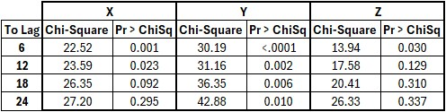
Figure 1
ACF and PACF plots for X products
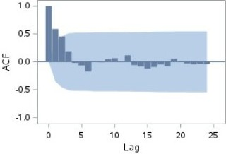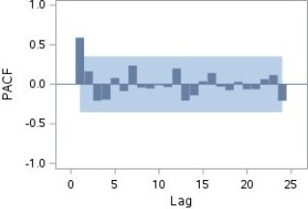
Figure 2
ACF and PACF plots for Y products
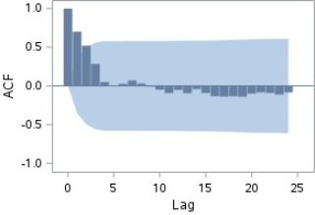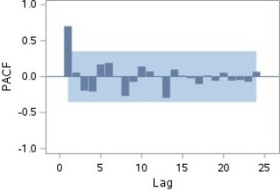
Figure 3
ACF and PACF plots for Z products
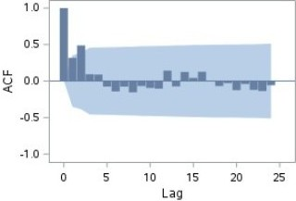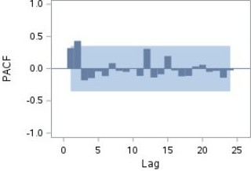
Taken together, these findings suggest that seasonality provides a minimal contribution to demand variability within specific categories and does not uniformly drive variability across all XYZ groups. Seasonality appears to play a moderate role for X and Y products, introducing cyclical demand patterns that can be modeled through seasonal time-series methods. However, the absence of seasonality in Z items implies that other factors account for their volatility. Therefore, the null hypothesis stating that seasonality has no significant effect on demand variability across XYZ categories cannot be rejected.
Conclusion
The findings of this project demonstrate that integrating ABC/XYZ classification with predictive analytics provides a useful yet flexible framework for improving inventory management. The ABC analysis revealed a highly concentrated profit distribution, where only a few products drove the majority of revenue which created a “super-Pareto” effect. This insight reinforces the strategic importance of maintaining optimal service levels for high-value, high-contribution items. Meanwhile, the XYZ classification exposed contrasts in demand stability with nearly half of products displaying near perfect demand stability while another large portion exhibited much higher levels of volatility.
The combination of these perspectives showed that most products occupy the low-profit, high-variability quadrant, underscoring the need for differentiated inventory policies. The seasonality assessment provided some clarity. Although some autocorrelation existed within X and Y products, its magnitude was not sufficient enough to explain overall demand variability. For Z products, no meaningful seasonal pattern was detected implying that their fluctuations stem from random or event-driven factors rather than predictable cycles. Therefore, seasonality cannot be considered a statistically significant determinant of demand variability across XYZ categories.
While this study provides valuable insights into the relationship between inventory classification and demand forecasting, several opportunities exist for further research. Time-series models, such as ARIMA or exponential smoothing, are best suited for X and Y categories, while Z items require simpler, stochastic approaches supported by robust safety-stock planning. The study illustrates how coupling traditional inventory classification with predictive analytics can help businesses transition from reactive to proactive inventory management, reducing waste, improving responsiveness, and strengthening supply-chain resilience.

References
ASCM. (2023). Supply chain analytics. Association for Supply Chain Management. https://www.ascm.org/topics/supply-chain-analytics/
Constante, F., Silva, F., & Pereira, A. (2019). DataCo smart supply chain for big data analysis. Mendeley Data. https://data.mendeley.com/datasets/8gx2fvg2k6/5
Davey, L. (2025). 7 supply chain issues: how to overcome them in 2024. Shopify. https://www.shopify.com/blog/supply-chain-issues
Falatouri, T., Darbanian, F., Brandtner, P., & Udokwu, C. (2022). Predictive analytics for demand forecasting – a comparison of SARIMA and LSTM in retail SCM. Procedia Computer Science, 200(2022), 993-1003. https://creativecommons.org/licenses/by-nc-nd/4.0
Geeks for Geeks. (2025). Autocorrelation and partial autocorrelation. https://www.geeksforgeeks.org/r-machine-learning/autocorrelation-and-partial-autocorrelation/
Ilias, V. & Reddy, P. G. (2025). Machine learning in supply chain management: systematic literature review and future research agenda. International Journal of Production Research 63(16), 5987-6016. https://doi.org/10.1080/00207543.2025.2466062
Investopedia. (2025). The Pareto Principle – aka the Pareto Rule or 80/20 Rule. https://www.investopedia.com/terms/p/paretoprinciple.asp
Lokad. (2023, April 12). ABC XYZ Analysis - Supply Chain in 3 minutes [Video]. YouTube. https://www.youtube.com/watch?v=2lBjZSzI6-A
Natsypayeva, E., Ivashina, M., Efremova, N., Chistyakova, S., & Melnichenko, V. (2020). Optimization of the assortment of retailers based on the use of ABC and XYZ analysis. Quality – Access to Success 21(179), 157-160.
Polonsky, M. J., & Waller, D. S. (2019). Designing and managing a research project: A business student's guide (4th ed.). SAGE Publications.
Ternero, R., Sepulveda-Rojas, J.P., Alfaro, M., Fuertes, G., & Vargas, M. (2023). Inventory management with stochastic demand: case study of a medical equipment company. South African Journal of Industrial Engineering 34(1), 131-142. https://dx.doi.org//10.4166/34-1-2668
Thieuleux, E. (2025). ABC XYZ analysis in inventory management: a complete guide with Excel example. AbcSupplyChain. https://abcsupplychain.com/abc-xyz-analysis/
Wardle, D. (n.d.). The role of data and analytics in supply chain management. Global Partner Solutions. https://www.gpsi-intl.com/blog/the-role-of-data-and-analytics-in-supply-chain-management/

